Suszczewicz Jarosław etap 3

1. W którym przypadku łatwiej wprowadzić zmiany w scenariuszach, np. zmienić dane do logowania?

**W testach automatycznych**

2. Jaki rodzaj testów wykonuje się za pomocą testów automatycznych?

**Testy jednostkowe , obciążeniowe**

3. Jakich rodzajów testów nie wykona się za pomocą testów automatycznych, lub będą one zbyt czasochłonne i mało efektywne, żeby je wykonywać?

**Testy pokrycia**

4. Jakie plusy i minusy automatyzacji dostrzegacie po wykonaniu laboratoriów, wymieńcie po 3 najważniejsze?   
  
**- testy automatyczne świetnie uzupełniają testy manualne**

**- obliczenia, które człowiekowi mogą sprawić wiele trudności przez maszynę zostaną przetworzone w ułamku sekundy**

**-powtarzalność - np. regresja**

**- komputery mają trudności z przetwarzaniem i interpretowaniem pewnych**

**informacji, które są naturalne dla człowieka**

**- obsługa automatycznego środowiska testowego wymaga sporych nakładów**

**- testy manualne często nie wymagają wiedzy z programowania**

5. Jaka jest różnica pomiędzy testami wydajnościowymi a obciążeniowymi?   
**Testy obciążeniowe określają np. jakie obciążenie moduł lub system jest w stanie obsłużyć  
(liczba równoległych pracujących użytkowników lub liczbie transakcji).  
  
testy wydajnościowe mają określić jak dany system lub moduł jest wydajny   
(efektywny np. względem czasu).**

6. Jakie są główne cechy automatyzacji testów?  
  
**- testy automatyczne świetnie uzupełniają testy manualne**

**- obliczenia, które człowiekowi mogą sprawić wiele trudności przez maszynę zostaną**

**przetworzone w ułamku sekundy**

**- powtarzalność - np. regresja**

**- wraz z upływem czasu organizm człowieka się męczy, spada koncentracja i coraz trudniej**

**jest mu ustrzec się błędów, automat się nie męczy**

**- mogą być uruchamiane cyklicznie (np. codziennie wraz z daily buildem oprogramowania)**

**- błędy związane z czynnikiem ludzkim praktycznie wyeliminowane**

**-w większości przypadków korzystają z napisanych skryptów.**

**Niestety mimo wielu podejść i kombinacji nie udało mi się zautomatyzować poprawnie testów.   
  
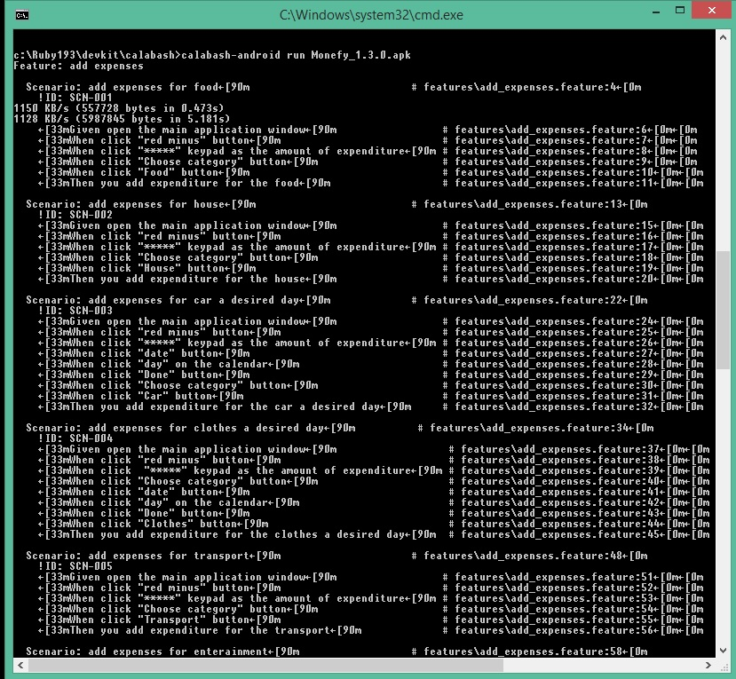**

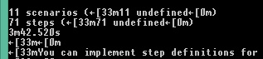

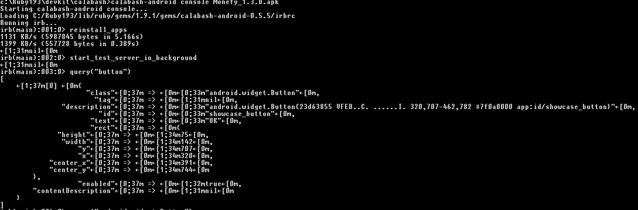

**c:\Ruby193\devkit\calabash>calabash-android run Monefy_1.3.0.apk**

**Feature: add expenses**

**Scenario: add expenses for food←[90m # features\add_expenses.feature:4←[0m**

**!ID: SCN-001**

**1150 KB/s (557728 bytes in 0.473s)**

**1128 KB/s (5987845 bytes in 5.181s)**

**←[33mGiven open the main application window←[90m # features\add_expenses.feature:6←[0m←[0m**

**←[33mWhen click "red minus" button←[90m # features\add_expenses.feature:7←[0m←[0m**

**←[33mWhen click "*****" keypad as the amount of expenditure←[90m # features\add_expenses.feature:8←[0m←[0m**

**←[33mWhen click "Choose category" button←[90m # features\add_expenses.feature:9←[0m←[0m**

**←[33mWhen click "Food" button←[90m # features\add_expenses.feature:10←[0m←[0m**

**←[33mThen you add expenditure for the food←[90m # features\add_expenses.feature:11←[0m←[0m**

**Scenario: add expenses for house←[90m # features\add_expenses.feature:13←[0m**

**!ID: SCN-002**

**←[33mGiven open the main application window←[90m # features\add_expenses.feature:15←[0m←[0m**

**←[33mWhen click "red minus" button←[90m # features\add_expenses.feature:16←[0m←[0m**

**←[33mWhen click "*****" keypad as the amount of expenditure←[90m # features\add_expenses.feature:17←[0m←[0m**

**←[33mWhen click "Choose category" button←[90m # features\add_expenses.feature:18←[0m←[0m**

**←[33mWhen click "House" button←[90m # features\add_expenses.feature:19←[0m←[0m**

**←[33mThen you add expenditure for the house←[90m # features\add_expenses.feature:20←[0m←[0m**

**Scenario: add expenses for car a desired day←[90m # features\add_expenses.feature:22←[0m**

**!ID: SCN-003**

**←[33mGiven open the main application window←[90m # features\add_expenses.feature:24←[0m←[0m**

**←[33mWhen click "red minus" button←[90m # features\add_expenses.feature:25←[0m←[0m**

**←[33mWhen click "*****" keypad as the amount of expenditure←[90m # features\add_expenses.feature:26←[0m←[0m**

**←[33mWhen click "date" button←[90m # features\add_expenses.feature:27←[0m←[0m**

**←[33mWhen click "day" on the calendar←[90m # features\add_expenses.feature:28←[0m←[0m**

**←[33mWhen click "Done" button←[90m # features\add_expenses.feature:29←[0m←[0m**

**←[33mWhen click "Choose category" button←[90m # features\add_expenses.feature:30←[0m←[0m**

**←[33mWhen click "Car" button←[90m # features\add_expenses.feature:31←[0m←[0m**

**←[33mThen you add expenditure for the car a desired day←[90m # features\add_expenses.feature:32←[0m←[0m**

**Scenario: add expenses for clothes a desired day←[90m # features\add_expenses.feature:34←[0m**

**!ID: SCN-004**

**←[33mGiven open the main application window←[90m # features\add_expenses.feature:37←[0m←[0m**

**←[33mWhen click "red minus" button←[90m # features\add_expenses.feature:38←[0m←[0m**

**←[33mWhen click "*****" keypad as the amount of expenditure←[90m # features\add_expenses.feature:39←[0m←[0m**

**←[33mWhen click "Choose category" button←[90m # features\add_expenses.feature:40←[0m←[0m**

**←[33mWhen click "date" button←[90m # features\add_expenses.feature:41←[0m←[0m**

**←[33mWhen click "day" on the calendar←[90m # features\add_expenses.feature:42←[0m←[0m**

**←[33mWhen click "Done" button←[90m # features\add_expenses.feature:43←[0m←[0m**

**←[33mWhen click "Clothes" button←[90m # features\add_expenses.feature:44←[0m←[0m**

**←[33mThen you add expenditure for the clothes a desired day←[90m # features\add_expenses.feature:45←[0m←[0m**

**Scenario: add expenses for transport←[90m # features\add_expenses.feature:48←[0m**

**!ID: SCN-005**

**←[33mGiven open the main application window←[90m # features\add_expenses.feature:51←[0m←[0m**

**←[33mWhen click "red minus" button←[90m # features\add_expenses.feature:52←[0m←[0m**

**←[33mWhen click "*****" keypad as the amount of expenditure←[90m # features\add_expenses.feature:53←[0m←[0m**

**←[33mWhen click "Choose category" button←[90m # features\add_expenses.feature:54←[0m←[0m**

**←[33mWhen click "Transport" button←[90m # features\add_expenses.feature:55←[0m←[0m**

**←[33mThen you add expenditure for the transport←[90m # features\add_expenses.feature:56←[0m←[0m**

**Scenario: add expenses for enterainment←[90m # features\add_expenses.feature:58←[0m**

**!ID: SCN-006**

**←[33mGiven open the main application window←[90m # features\add_expenses.feature:61←[0m←[0m**

**←[33mWhen click "red minus" button←[90m # features\add_expenses.feature:62←[0m←[0m**

**←[33mWhen click "*****" keypad as the amount of expenditure←[90m # features\add_expenses.feature:63←[0m←[0m**

**←[33mWhen click "Choose category" button←[90m # features\add_expenses.feature:64←[0m←[0m**

**←[33mWhen click "Entertainment" button←[90m # features\add_expenses.feature:65←[0m←[0m**

**←[33mThen you add expenditure for the entertainment←[90m # features\add_expenses.feature:66←[0m←[0m**

**Scenario: add expenses for taxi←[90m # features\add_expenses.feature:68←[0m**

**!ID: SCN-007**

**←[33mGiven open the main application window←[90m # features\add_expenses.feature:71←[0m←[0m**

**←[33mWhen click "taxi" image←[90m # features\add_expenses.feature:72←[0m←[0m**

**←[33mWhen click "*****" keypad as the amount of expenditure←[90m # features\add_expenses.feature:73←[0m←[0m**

**←[33mWhen click "Add'Taxi'" button←[90m # features\add_expenses.feature:74←[0m←[0m**

**←[33mThen you add expenditure for the taxi←[90m # features\add_expenses.feature:75←[0m←[0m**

**Scenario: add expenses for toiletry←[90m # features\add_expenses.feature:77←[0m**

**!ID: SCN-008**

**←[33mGiven open the main application window←[90m # features\add_expenses.feature:80←[0m←[0m**

**←[33mWhen click "toothbrush cup" image←[90m # features\add_expenses.feature:81←[0m←[0m**

**←[33mWhen click "*****" keypad as the amount of expenditure←[90m # features\add_expenses.feature:82←[0m←[0m**

**←[33mWhen click "Add'Toiletry''" button←[90m # features\add_expenses.feature:83←[0m←[0m**

**←[33mThen you add expenditure for the toiletry←[90m # features\add_expenses.feature:84←[0m←[0m**

**Scenario: add expenses 0 $ for eating out←[90m # features\add_expenses.feature:86←[0m**

**!ID: SCN-009**

**←[33mGiven open the main application window←[90m # features\add_expenses.feature:89←[0m←[0m**

**←[33mWhen click "fork knife" image←[90m # features\add_expenses.feature:90←[0m←[0m**

**←[33mWhen cilck "0" keypad as the amount of expenditure←[90m # features\add_expenses.feature:91←[0m←[0m**

**←[33mWhen click "Add 'Eating out'" button←[90m # features\add_expenses.feature:92←[0m←[0m**

**←[33mThen the value of the cost of the background is red←[90m # features\add_expenses.feature:93←[0m←[0m**

**Scenario: add expenses 0.0 $ for eating out←[90m # features\add_expenses.feature:95←[0m**

**!ID: SCN-010**

**←[33mGiven open the main application window←[90m # features\add_expenses.feature:98←[0m←[0m**

**←[33mWhen click "fork knife" image←[90m # features\add_expenses.feature:99←[0m←[0m**

**←[33mWhen click "0." keypad as the amount of expenditure←[90m # features\add_expenses.feature:100←[0m←[0m**

**←[33mWhen click "Add 'Eating out'" button←[90m # features\add_expenses.feature:101←[0m←[0m**

**←[33mThen the value of the cost of the background is red←[90m # features\add_expenses.feature:102←[0m←[0m**

**Scenario: add expenses for health←[90m # features\add_expenses.feature:104←[0m**

**!ID: SCN-011**

**←[33mGiven open the main application window←[90m # features\add_expenses.feature:107←[0m←[0m**

**←[33mWhen click "red minus" button←[90m # features\add_expenses.feature:108←[0m←[0m**

**←[33mWhen click "add note" text←[90m # features\add_expenses.feature:109←[0m←[0m**

**←[33mWhen enter "*****" as note←[90m # features\add_expenses.feature:110←[0m←[0m**

**←[33mWhen click "ok" button←[90m # features\add_expenses.feature:111←[0m←[0m**

**←[33mWhen click "*****" keypad as the amount of expenditure←[90m # features\add_expenses.feature:112←[0m←[0m**

**←[33mWhen click "Choose category" button←[90m # features\add_expenses.feature:113←[0m←[0m**

**←[33mWhen click "Health" button←[90m # features\add_expenses.feature:114←[0m←[0m**

**←[33mThen you add expenditure for the health←[90m # features\add_expenses.feature:115←[0m←[0m**

**11 scenarios (←[33m11 undefined←[0m)**

**71 steps (←[33m71 undefined←[0m)**

**3m42.520s**

**←[33m←[0m**

**←[33mYou can implement step definitions for undefined steps with these snippets:←[0m**

**←[33m←[0m**

**←[33mGiven(/^open the main application window$/) do←[0m**

**←[33m pending # express the regexp above with the code you wish you had←[0m**

**←[33mend←[0m**

**←[33m←[0m**

**←[33mWhen(/^click "(.*?)" button$/) do |arg1|←[0m**

**←[33m pending # express the regexp above with the code you wish you had←[0m**

**←[33mend←[0m**

**←[33m←[0m**

**←[33mWhen(/^click "(.*?)" keypad as the amount of expenditure$/) do |arg1|←[0m**

**←[33m pending # express the regexp above with the code you wish you had←[0m**

**←[33mend←[0m**

**←[33m←[0m**

**←[33mThen(/^you add expenditure for the food$/) do←[0m**

**←[33m pending # express the regexp above with the code you wish you had←[0m**

**←[33mend←[0m**

**←[33m←[0m**

**←[33mThen(/^you add expenditure for the house$/) do←[0m**

**←[33m pending # express the regexp above with the code you wish you had←[0m**

**←[33mend←[0m**

**←[33m←[0m**

**←[33mWhen(/^click "(.*?)" on the calendar$/) do |arg1|←[0m**

**←[33m pending # express the regexp above with the code you wish you had←[0m**

**←[33mend←[0m**

**←[33m←[0m**

**←[33mThen(/^you add expenditure for the car a desired day$/) do←[0m**

**←[33m pending # express the regexp above with the code you wish you had←[0m**

**←[33mend←[0m**

**←[33m←[0m**

**←[33mWhen(/^click "(.*?)" keypad as the amount of expenditure$/) do |arg1|←[0m**

**←[33m pending # express the regexp above with the code you wish you had←[0m**

**←[33mend←[0m**

**←[33m←[0m**

**←[33mThen(/^you add expenditure for the clothes a desired day$/) do←[0m**

**←[33m pending # express the regexp above with the code you wish you had←[0m**

**←[33mend←[0m**

**←[33m←[0m**

**←[33mThen(/^you add expenditure for the transport$/) do←[0m**

**←[33m pending # express the regexp above with the code you wish you had←[0m**

**←[33mend←[0m**

**←[33m←[0m**

**←[33mThen(/^you add expenditure for the entertainment$/) do←[0m**

**←[33m pending # express the regexp above with the code you wish you had←[0m**

**←[33mend←[0m**

**←[33m←[0m**

**←[33mWhen(/^click "(.*?)" image$/) do |arg1|←[0m**

**←[33m pending # express the regexp above with the code you wish you had←[0m**

**←[33mend←[0m**

**←[33m←[0m**

**←[33mThen(/^you add expenditure for the taxi$/) do←[0m**

**←[33m pending # express the regexp above with the code you wish you had←[0m**

**←[33mend←[0m**

**←[33m←[0m**

**←[33mThen(/^you add expenditure for the toiletry$/) do←[0m**

**←[33m pending # express the regexp above with the code you wish you had←[0m**

**←[33mend←[0m**

**←[33m←[0m**

**←[33mWhen(/^cilck "(.*?)" keypad as the amount of expenditure$/) do |arg1|←[0m**

**←[33m pending # express the regexp above with the code you wish you had←[0m**

**←[33mend←[0m**

**←[33m←[0m**

**←[33mThen(/^the value of the cost of the background is red$/) do←[0m**

**←[33m pending # express the regexp above with the code you wish you had←[0m**

**←[33mend←[0m**

**←[33m←[0m**

**←[33mWhen(/^click "(.*?)" text$/) do |arg1|←[0m**

**←[33m pending # express the regexp above with the code you wish you had←[0m**

**←[33mend←[0m**

**←[33m←[0m**

**←[33mWhen(/^enter "(.*?)" as note$/) do |arg1|←[0m**

**←[33m pending # express the regexp above with the code you wish you had←[0m**

**←[33mend←[0m**

**←[33m←[0m**

**←[33mThen(/^you add expenditure for the health$/) do←[0m**

**←[33m pending # express the regexp above with the code you wish you had←[0m**

**←[33mend←[0m**

**c:\Ruby193\devkit\calabash>**